# **Getting Started**

WordPress makes it simpler and quicker to manage book libraries.

To get started with the free book library plugin, you must first install the plugin from the WordPress plugin directory. For this, **download the plugin from below github link and upload in plugin.**

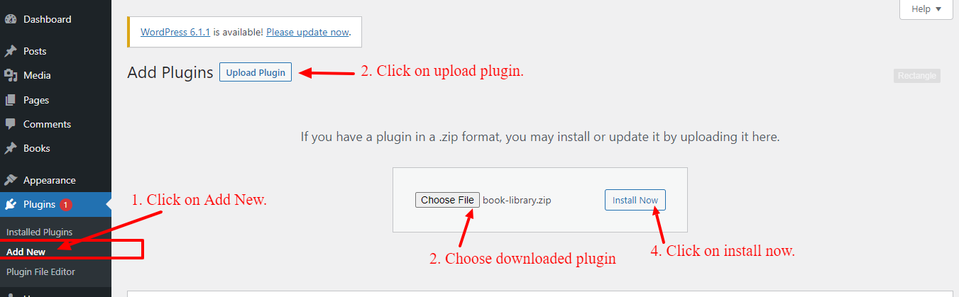

Once it is installed, click on the ‘**Activate**’ button. This will enable Book Library for your WordPress website.

# 

# **Manage Books**

Learn about how to manage books for the library in the books menu.

To add new books, go to **Books** menu then click on **Add New**.

Then you can add title, description, price, rating, publisher and authors. After click on update to save books.

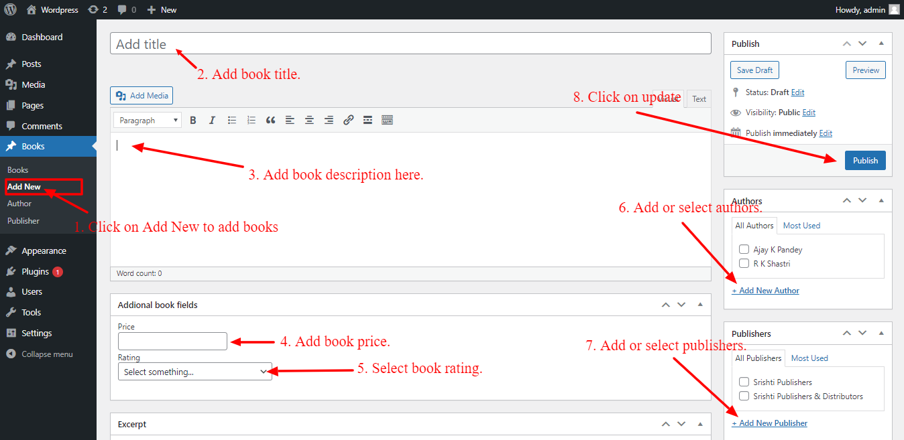

In the books menu, you can see a list of books that are added. You can also edit, delete or view from this listing.

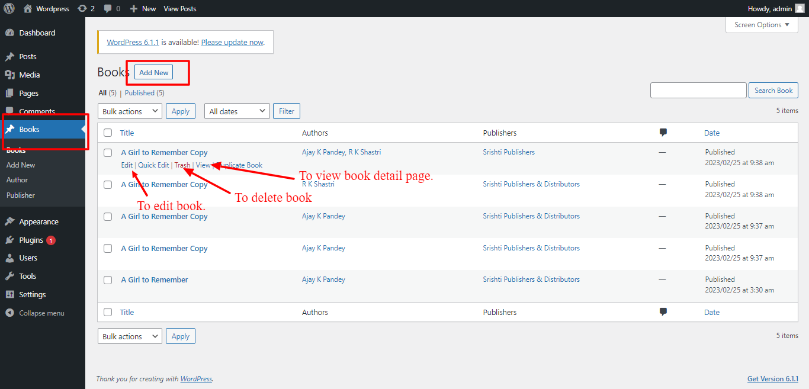

To Manage authors, click on the Author menu. Then on the right side you can add a new author by adding a name. On the left side you can see a list of added authors.

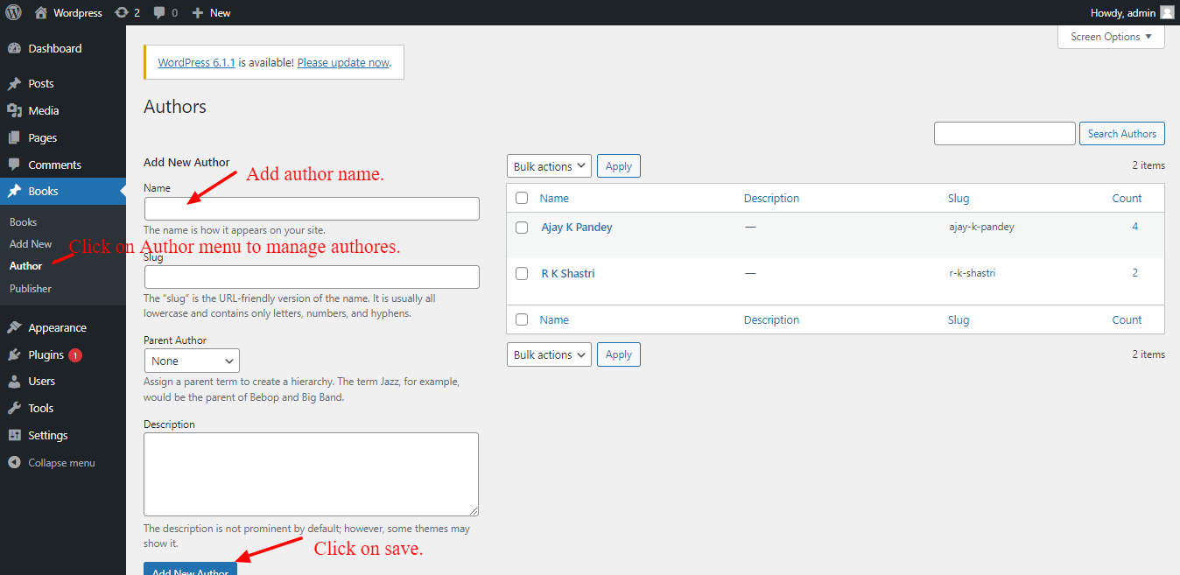

To Manage publishers, click on the Publisher menu. Then on the right side you can add a new publisher by adding a name. On the left side you can see a list of added publishers.

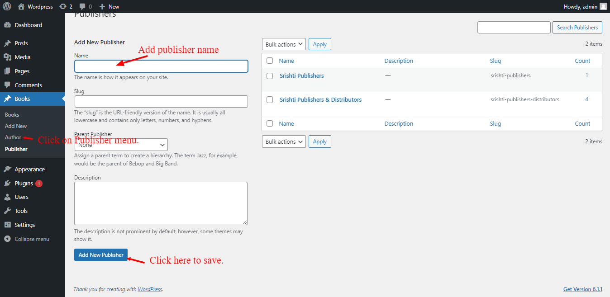

# **Shortcode**

Learn about how to add shortcodes in the page to display in front.

Here is the shortcode:

[wp_bl_book_library search_title="Book Search" pagination="2"]

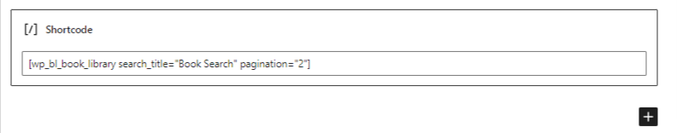.

* **search_title**: You can give the search title name by passing it in this parameter in the shortcode.
* **pagination**: This parameter is used to display the number of books in the list and manage pagination.

